Graded Assignment

on

Networking and Servers

Course 3: Networking and Servers | DevOps B4
Question 1:
Deploy a website on localhost using either apache2 or Nginx. Create a DNS name for this website as ‘awesomeweb’. You can use any web template you want or can write your own simple HTML code. Write detailed documentation with the steps involved.

Prerequisites:
- A computer with a Linux operating system (e.g., Ubuntu).
- Basic understanding of terminal commands.

Steps:

1. Open your terminal and update package lists. If packages can be upgraded, then upgrade it.
sudo apt update
Sudo apt upgrade -y
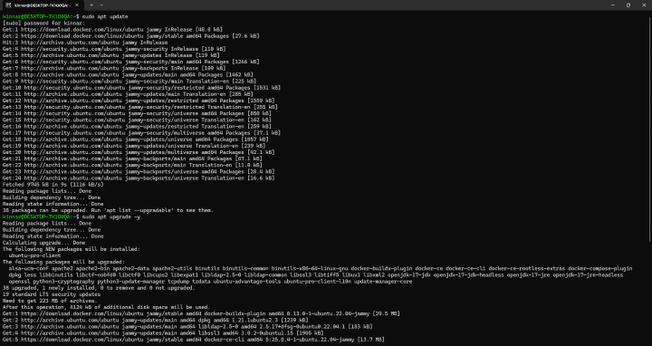

2. Install Nginx:
sudo apt install nginx
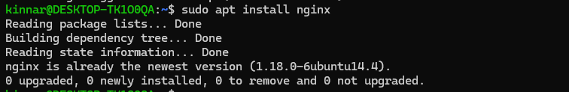

3. Create a Test Website:
Create a directory for your website files (e.g., /var/www/html/awesomeweb).
We'll use a simple HTML file for demonstration.
sudo mkdir -p /var/www/html/awesomeweb
4. Create an index.html file inside the directory with your preferred content.
HTML Code Block:
<!DOCTYPE html>
<html>
<head>
<title>Awesome Website</title>
</head>
<body>
<h1>Welcome to my awesome website!</h1>
</body>
</html>
Note: You can replace this code with any HTML content you want for your website.

5. Configure Nginx Server Block:
Create a new server block configuration file:
sudo nano /etc/nginx/sites-available/awesomeweb.conf
Nginx Server Block
server {
listen 80;
server_name localhost.awesomeweb.com;
location / {
root /var/www/html/awesomeweb;
index index.html index.htm;
}
error_log /var/log/nginx/awesomeweb_error.log;
access_log /var/log/nginx/awesomeweb_access.log;
}
Save and close the file.
6. Enable the Server Block:
Create a symbolic link from the available configuration file to the enabled sites directory:
sudo ln -s /etc/nginx/sites-available/awesomeweb.conf /etc/nginx/sites-enabled/

7. Test Nginx Configuration:
Check the Nginx configuration for syntax errors:
sudo nginx -t
If there are no errors, proceed to the next step. Otherwise, fix the errors in your configuration file and re-run the test command.

8. Restart Nginx:
sudo systemctl restart nginx

9. Configure Local DNS (hosts file):
Open the hosts file for editing:
sudo nano /etc/hosts
Add a new line at the bottom with the following format:
127.0.0.1 localhost.awesomeweb.com
Note: Replace awesomeweb with your desired DNS name for the website.
Save and close the file.

10. Testing Your Website:

Open a web browser and navigate to http://localhost.awesomeweb.com/ (or your chosen DNS name) in the address bar.

You should see your website content below if everything is set up correctly.
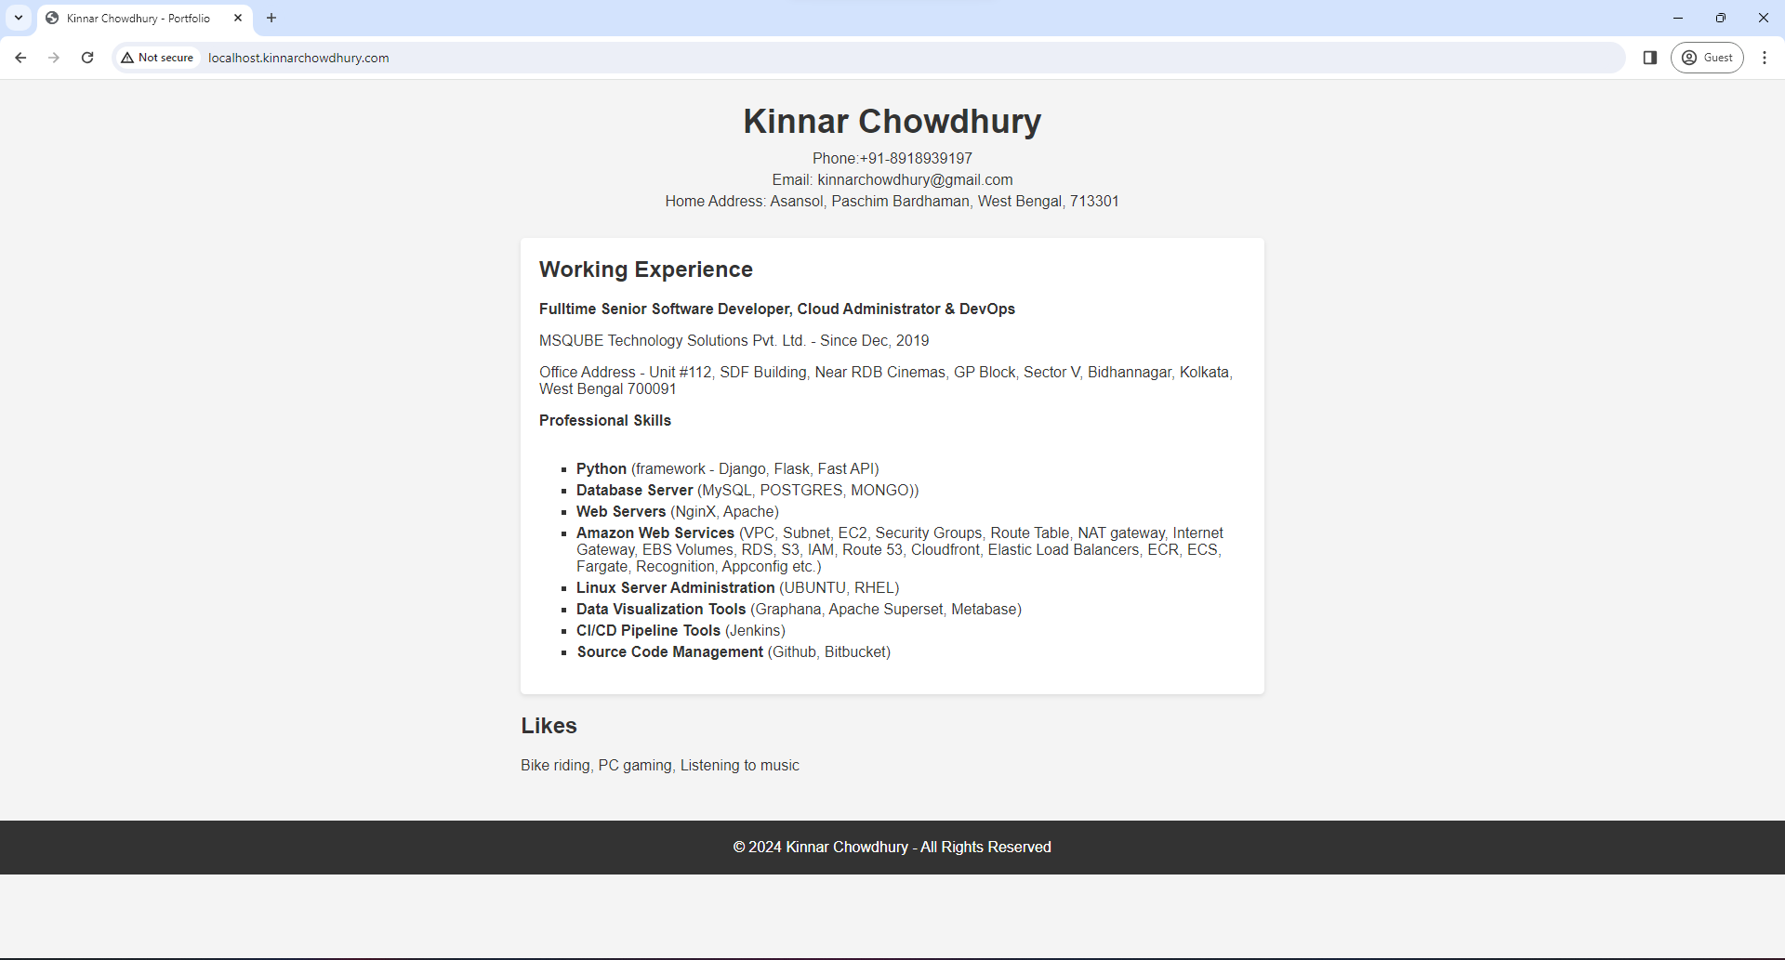
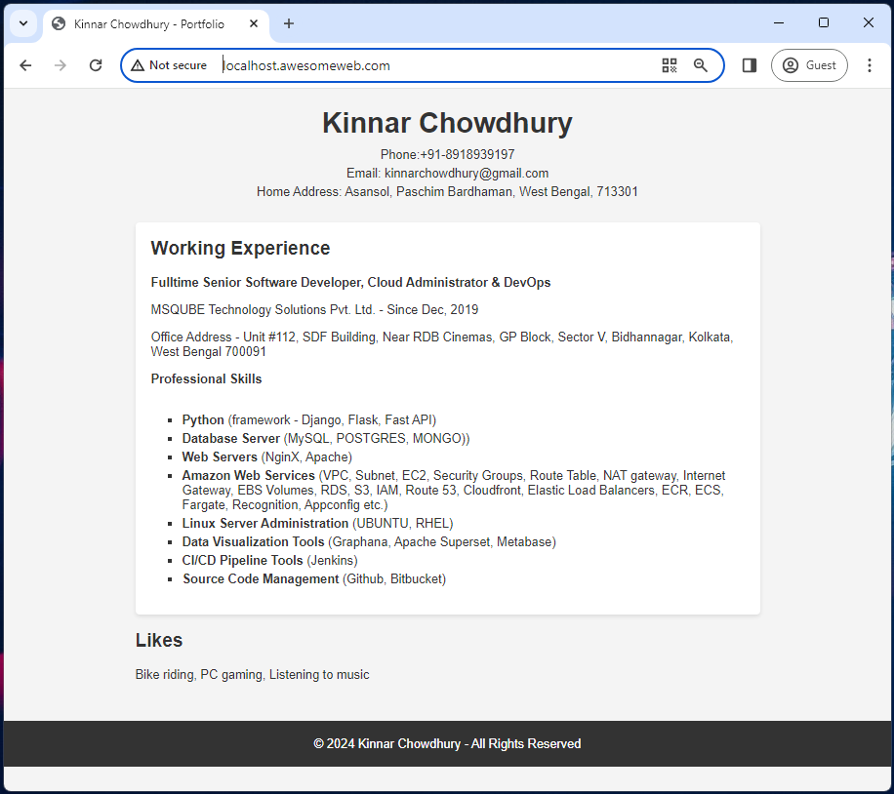
THANK YOU
============================ End of File ============================

